Lifecycle Greenhouse Gas Emissions Assessment Guidance Document
Renewable Fuels Production Tax Credit

Background
In 2022, the Hawai‘i State Legislature passed Act 216 Relating to Taxation. The Act reinstates the renewable fuel production tax credit (RFPTC), originally established in 2016 under Act 202 and repealed on December 31, 2021. Act 216 amends Hawai‘i Revised Statutes Chapter 235. The amended language states that “the tax credit shall only be claimed for fuels with lifecycle emissions below that of fossil fuels”. Under the new (RFPTC) law the taxpayer is required, at its sole expense, to provide information to the Hawai‘i State Energy Office on the feedstock used for each type of qualified fuel and the lifecycle greenhouse gas emissions per British thermal units for each type of qualified fuel produced.
The Act further requires the Hawai‘i State Energy Office (HSEO) to “provide the taxpayer with a determination of whether the lifecycle greenhouse gas emissions for each type of qualified fuel produced is lower than that of fossil fuels.”

HSEO Process and Evaluation
To determine whether the renewable fuels (the production of which forms the basis for the taxpayer) applying for tax credits have lifecycle emissions less than that of fossil fuels, HSEO will determine greenhouse gas intensity values for the fossil fuel most likely to be replaced by the renewable fuel seeking tax credit, as provided by the taxpayer and verified by HSEO. As an example, fuels providing electricity to the grid will be compared to the dominant fossil fuel supplying each island's power plants, as presented in the lifecycle assessment for the Par Hawai‘i Fuel Contract, Docket 2020-0090. Fuels intended to replace synthetic natural gas (SNG) will be compared to emissions from the SNG lifecycle assessment of the greenhouse gas lifecycle assessment of the PAR Petroleum feedstock agreement, submitted in docket 2020-0158. The greenhouse gas lifecycle intensity values are expressed as carbon dioxide equivalent per British thermal unit (CO₂e/btu). Lifecycle Greenhouse Gas Results from the US EPA can be viewed as a reference for target baselines for various fuel types. HSEO provides this as a resource only to demonstrate the variation in lifecycle emissions of different fuels. HSEO will use Hawai‘i specific data and published lifecycle assessments to determine the greenhouse gas intensity of the fossil fuel used for comparison.
The GHG emissions are broken down into stages including upstream (oil production), midstream (oil refining), transportation (to, within, and from Hawai‘i), and operations (use, or operational emissions). To compare emission intensities, the same stages shall be used in the LCA for renewable fuels, as described below.

Taxpayer Submittal Requirements
Taxpayers seeking credit for renewable fuels production shall provide a lifecycle analysis including lifecycle emissions for each of the stages defined below for each fuel they are seeking tax credit. HSEO notes certain stages may not be applicable for certain fuels (e.g., waste fuels). HSEO defines the stages of renewable fuel production as follows:
- Upstream emissions shall include “cradle to farm-gate activities.” These include farm input manufacturing emissions including energy requirements for equipment, emissions from feedstock production including energy inputs for farming activities, raw material inputs, fertilizer input, agrochemical usage, carbon dioxide emissions from lime/urea application, and nitrous oxide emissions from soils.
  - Waste fuels sourced entirely as a by-product of waste materials, or waste gas (e.g., waste cooking oil or gas produced from byproducts of wastewater treatment) may assume a zero value for upstream emissions.
- Midstream emissions shall include emissions from feedstock conversion and fuel production (if applicable).
- Transportation emissions include transportation to, within, and from Hawai‘i.
- Operation emissions shall include both tailpipe (combustion emissions) and storage emissions for fuel producers who sell their produced fuel to end-users – such as biodiesel for use in light, medium, and heavy-duty vehicles.
Final lifecycle greenhouse gas emissions values shall be presented for each of the following stages, expressed as CO₂e/btu. A total value or summation of all stages shall also be provided.
Using this value, HSEO will determine whether the fuel(s) has lifecycle emissions “less than that of fossil fuels.”
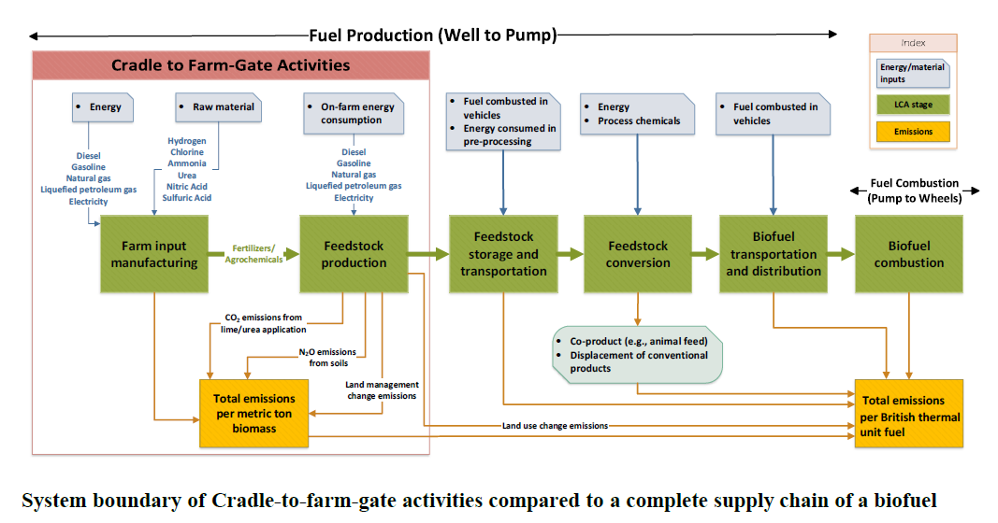
Figure 1: Example system boundaries to include in the lifecycle analysis of biofuels. Source: Liu, Kwon, Wang. 2021. Argonne National Laboratory, Energy Systems Division Feedstock Carbon Intensity Calculator, Technical Guidance Document.
In accordance with EPA guidelines, the lifecycle assessment of fuel production should not include activities that are unrelated to the fuel lifecycle (e.g., offset projects) or emissions associated with physical and organizational infrastructure (e.g., facility construction, employees commuting to the facility).
Within the required Independent Third-Party Certification Statement (ITPCS), the taxpayer shall identify the fossil fuel most likely to be replaced by the renewable fuel that its producing. Taxpayer shall also identify the anticipated end use for the fuel.

Acceptable Sources
HSEO recommends using the GREET 2021 model available from Argonne National Laboratory when conducting the LCA, for upstream, midstream, and transportation emissions. The GREET 2021 model is a universally used and accepted standard nationally, and among many states for conducting emissions calculations. Other models that may be appropriate include the Feedstock Carbon Intensity Calculator (FD-CIC) tool, which is included in the 2021 GREET model. Taxpayers can contact the Hawai‘i State Energy office regarding the acceptability of the chosen model.
EPA Emission Factors for Greenhouse Gas Inventories (40 CFR Part 98) should be used in the chosen model as appropriate. The EPA’s Emission Factors are widely recognized as an acceptable resource that is aligned with federal standards and practices used in other states. A list of Emissions Factors is available from the EPA’s GHG Emission Factors Hub. HSEO requests that these factors be used to determine GHG lifecycle intensity to be consistent with federal guidelines, and the practices of other states.,
Please note that, the LCA will be completed by an independent third-party qualified to conduct lifecycle analysis. HSEO requires the calculations, models, and/or spreadsheets (with formulas included as applicable) used to complete the LCA.

Disclaimer
HSEO reserves the right to update the comparative fossil fuel values to follow information updated in the previous year or years. HSEO obtained Lifecycle Assessment (LCA) Values from dockets active or closed at the Public Utilities Commission.
Assessment of fuel production will not include activities that are unrelated to the fuel lifecycle (e.g., offset projects).
If proprietary software is used to determine lifecycle greenhouse gas emissions, the applicant and/or independent third-party certifier must be able to demonstrate the data inputs, assumptions, methodology, and calculations used to determine GHG emissions at each lifecycle stage.

PUC Docket 2020-0090, Hawaiian Electric Companies For Approval of a First Amendment to Fuel Supply Contract with Par Hawaii Submission of Greenhouse Gas Report for Interim Phase of Proceeding. July 10, 2020.
PUC Docket 2020-0158, Application of The Gas Company, LLC. Dba Hawai‘i Gas for Approval of Par Hawai‘i Refining, LLC, etc. Submittal of Greenhouse Gas Life-Cycle Assessment. October 30, 2020.
https://greet.es.anl.gov/files/greet-2021-summary
EPA Renewable Fuels Standard Program. 40 CFR Subpart M https://www.epa.gov/renewable-fuel-standard-program
LCFS Life Cycle Analysis Models and Documentation. California Air Resources Board Available at: https://ww2.arb.ca.gov/resources/documents/lcfs-life-cycle-analysis-models-and-documentation
EPA RPS standard practice https://www.epa.gov/renewable-fuel-standard-program/lifecycle-analysis-greenhouse-gas-emissions-under-renewable-fuel

